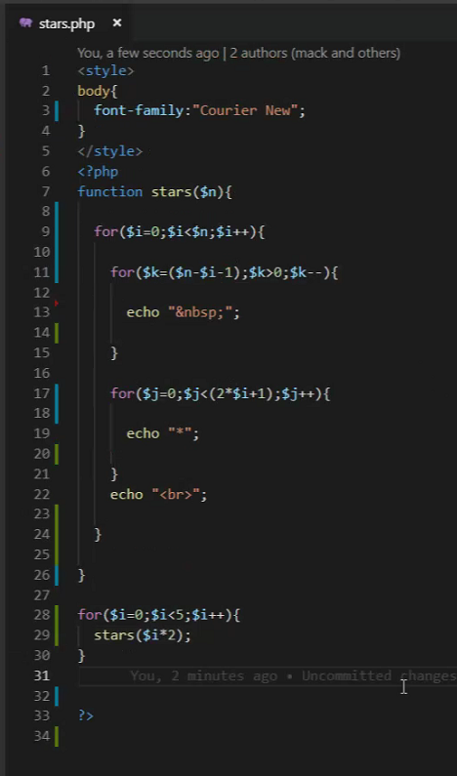

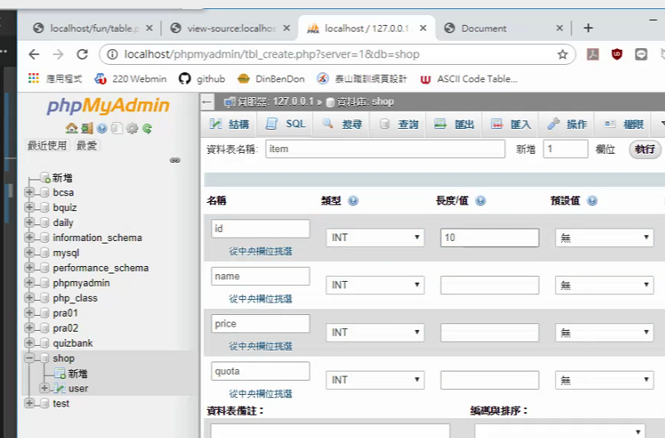

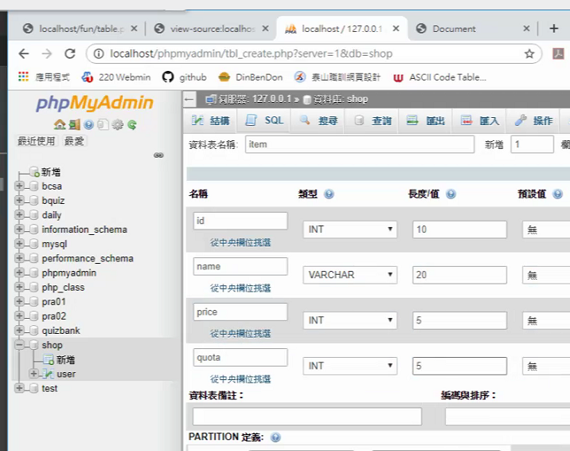

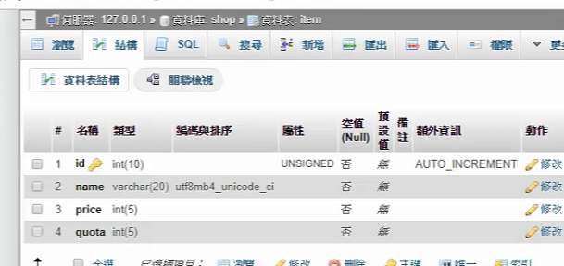

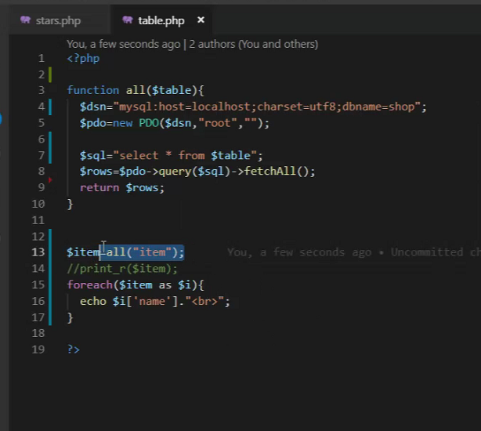

fetchAll() 只拿一筆資料

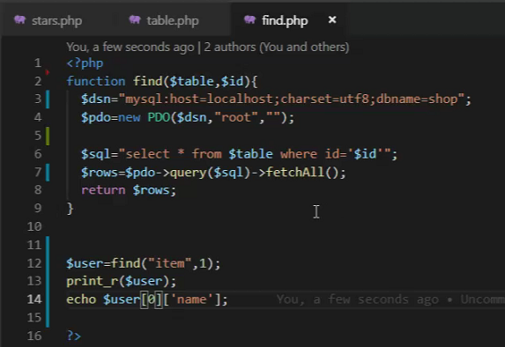

fetchAll()

echo $user[0][‘name’]

Fetch() 用法



<?php

function find($table,$id){

$dsn="mysql:host=localhost;charset=utf8;dbname=shop";

$pdo=new PDO($dsn,"root","");

$sql="select * from $table where id='$id'";

$rows=$pdo->query($sql)->fetch();

return $rows;

}

$user=find("user",1);

print_r();

echo $user['name'];

?>

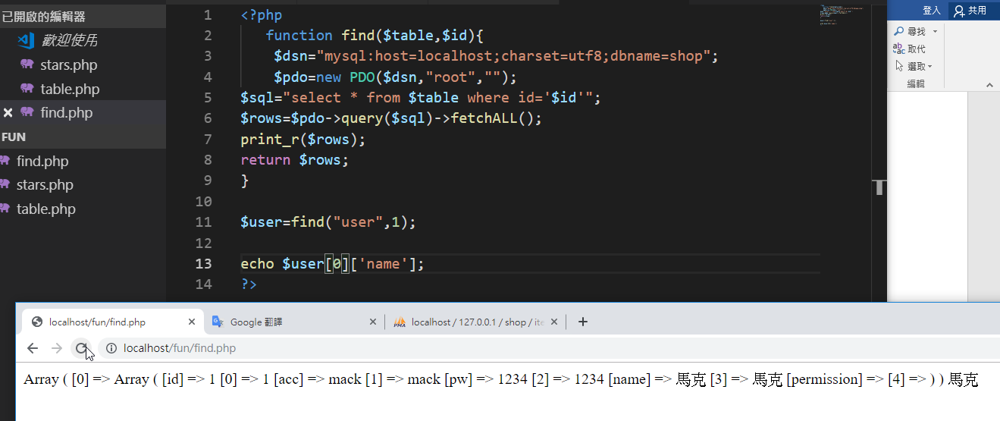

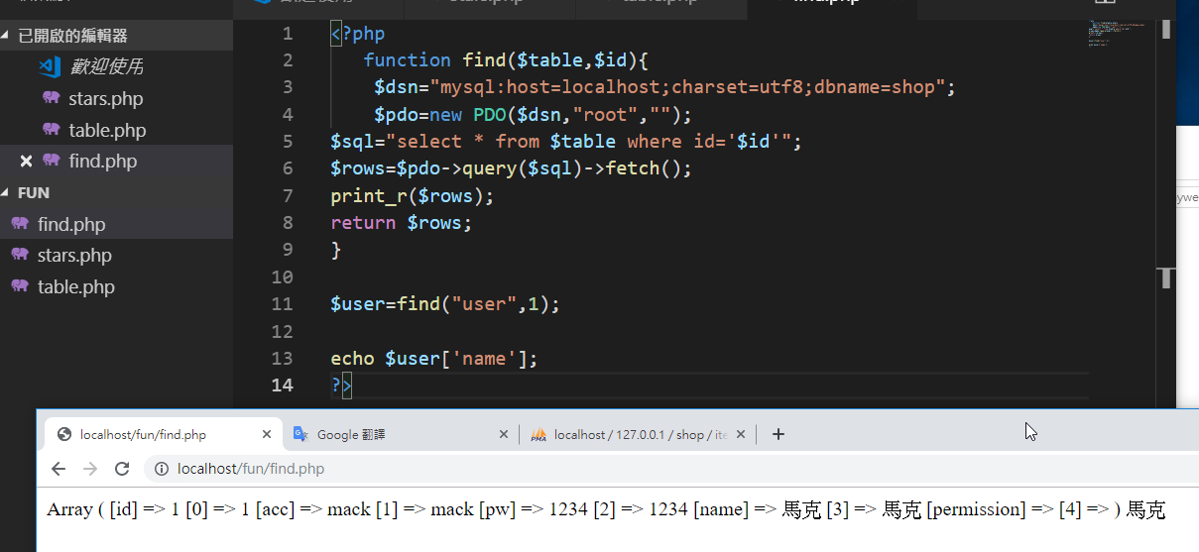

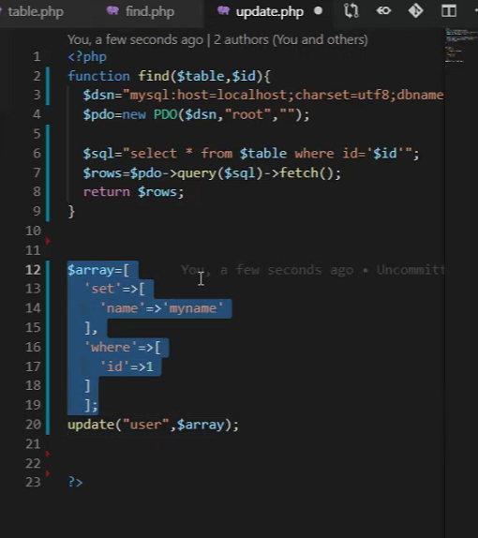

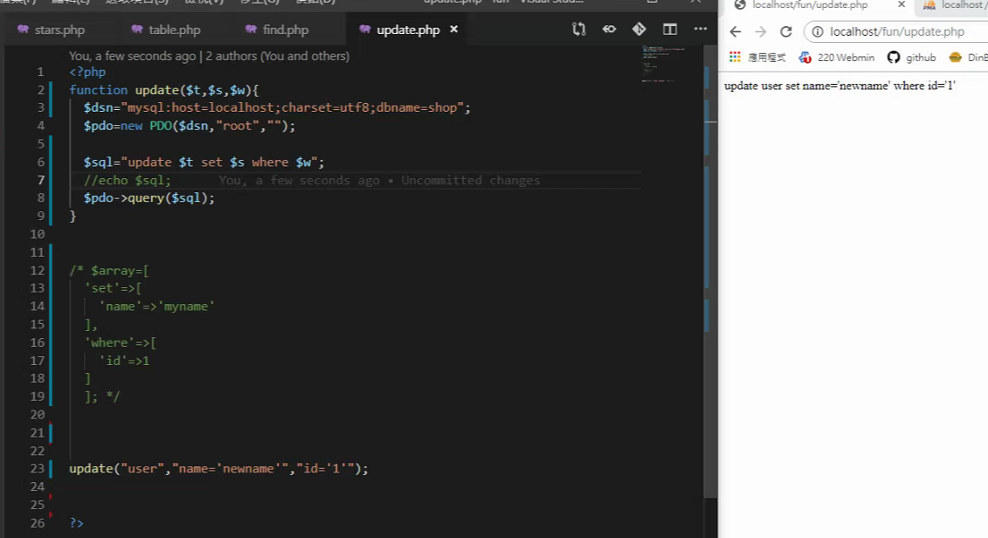

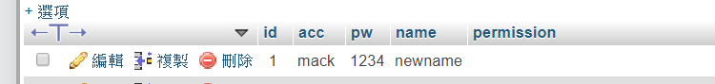

<?php

function update($t,$s,$w){

$dsn="mysql:host=localhost;charset=utf8;dbname=shop";

$pdo=new PDO($dsn,"root","");

$sql="update $t set $s where $w";

echo $sql;

$pdo->query($sql);

//print_r($rows);

}

update("user","name='newname'","id='1'");

<http://www.runoob.com/php/pdo-exec.html>

<?php

function update($t,$s,$w){

$dsn="mysql:host=localhost;charset=utf8;dbname=shop";

$pdo=new PDO($dsn,"root","");

$sql="update $t set $s where $w";

echo $sql;

$result=$pdo->exec($sql); //改用exec來回傳受影響的資料筆數

return $result;

//print_r($rows);

}

echo update("user","name='name'","id='1'");

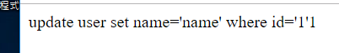

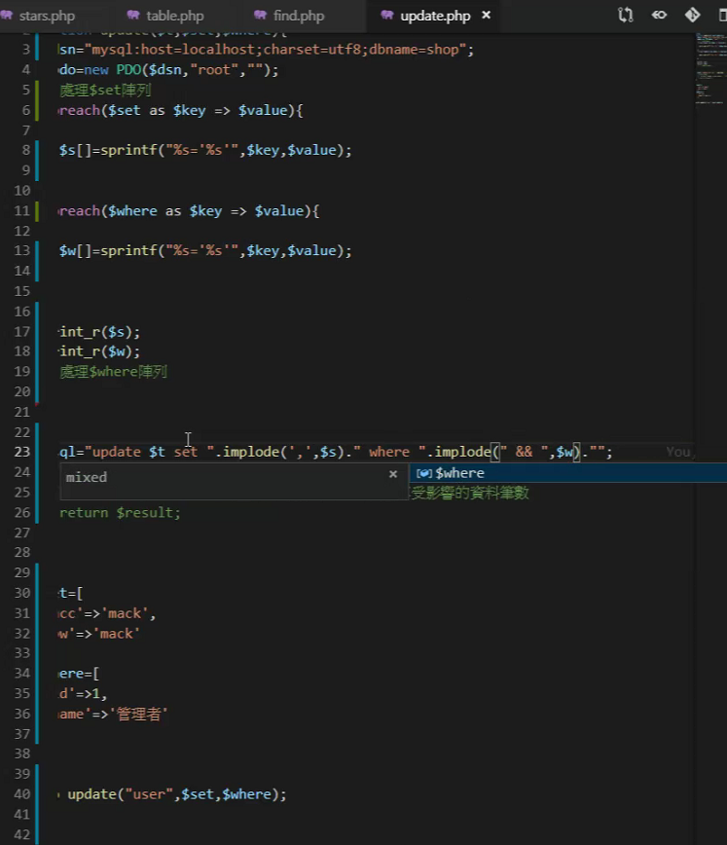

<?php

function update($t,$set,$where){

$dsn="mysql:host=localhost;charset=utf8;dbname=shop";

$pdo=new PDO($dsn,"root","");

//處理$set 陣列

foreach($set as $key => $value){

$s[]=sprintf("%s='%s'",$key,$value);

}

//處理$where陣列

foreach($where as $key => $value){

$w[]=sprintf("%s='%s'",$key,$value);

}

//print_r($s);

//print_r($w);

//$sql="update $t set $s where $w";

$sql="update $t set ".implode(',',$s)." where ".implode(" && ",$w)."";

echo $sql;

$result=$pdo->exec($sql); //改用exec來回傳受影響的資料筆數

return $result;

//print_r($rows);

}

$set=[

'name'=>'mack',

'pw'=>'mack'

];

$where=[

'id'=>1

];

echo update("user",$set,$where);

?>

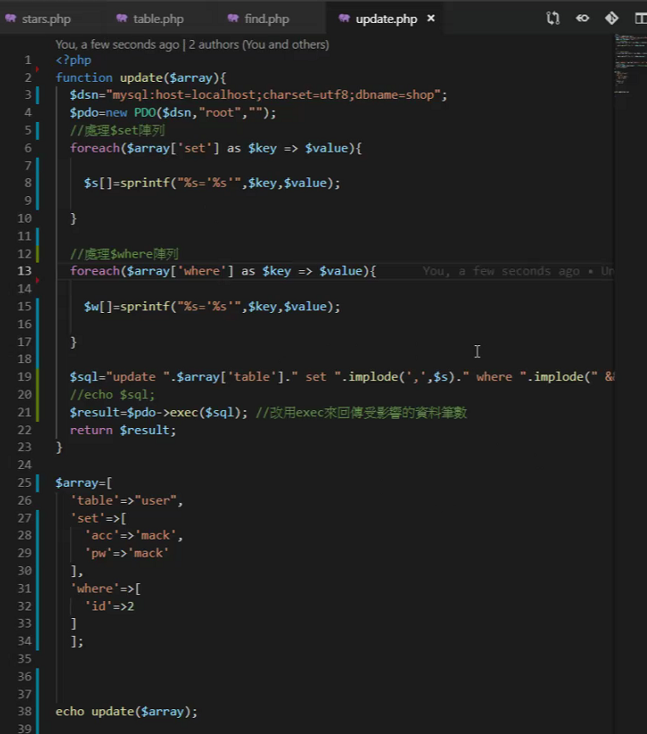

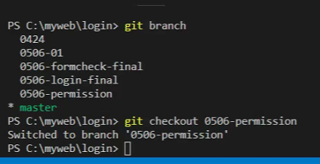

<http://www.webtech.tw/info.php?tid=69>

